1. Explain DAX.

DAX is a collection of functions, operators, and constants that can be used in a formula, or expression, to calculate and return one or more values. Stated more simply, DAX helps you create new information from data already in your model.

1. Explain datasets, reports, and dashboards and how they relate to each other?

**Reports**

A**Report** is a multi-perspective view of a dataset, with visuals representing different findings and insights. A report can have one visual or pages full of visuals. Depending on the role of your job, you may be someone who designs reports.

**Reports In Power BI Desktop**

In the Power BI Desktop ***Report view***, you can create any number of report pages with visualizations. **Report view** in Power BI Desktop provides a similar design experience to the Report’s editing view in the *Power BI service.*

## Dashboards

A PowerBI dashboard is a single page, often called a canvas, telling a story through visualizations. Because it is limited to only one page, a well-designed dashboard contains only the highlights of that story.

Dashboards aren’t available in the Power BI Desktop, and they are only available in the Power BI Service. You can also view a dashboard on mobile but can’t create dashboards on mobile.

## DATA SET

 Power BI Dataset is a series of Power Query queries that have been shaped in a DAX model. Each dataset can combine different files, database tables and online services all into one tabular model.  In our cookie analogy, these are all different “ingredients”.

Unlike SSRS, a dataset in Power BI does not represent a single table or query of data. A dataset should be considered more like a “flavor” of data used to accomplish a specific type of reporting: financial, operational, HR, etc. So in our analogy, the dataset is the “raw dough”.

1. How reports can be created in power BI, explain two ways with Navigation of each.

There are several ways to create reports quickly in the Power BI service. Instead of downloading the Power BI Desktop app and importing the data, you can paste data straight into Power BI on the web, and Power BI automatically generates visuals for you.

## Ways to create reports

Continue reading this article for the basics of [creating quick reports](https://learn.microsoft.com/en-us/power-bi/create-reports/service-quick-create-report#create-a-quick-report). These other articles are about reports based on specific kinds of data:

* [Create a report from an Excel file](https://learn.microsoft.com/en-us/power-bi/create-reports/service-report-create-new) in the Power BI service
* [Create a report quickly from a SharePoint list or library](https://learn.microsoft.com/en-us/power-bi/create-reports/service-quick-create-sharepoint-list)
* [Create a report quickly from Dynamics 365](https://learn.microsoft.com/en-us/power-bi/create-reports/dynamics-quick-create-report)
* [Interact with autogenerated "quick" reports](https://learn.microsoft.com/en-us/power-bi/create-reports/service-interact-quick-report) in the Power BI service

## Create a quick report

In the navigation pane in the Power BI service, you can select the **Create** button that opens a page where you can select your data source. It's also accessible from the **New report** button on Home.

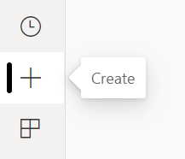

Currently, we only support creating a report based on an existing dataset, or pasting or manually entering data directly in a table. Over time you'll see other sources, such as uploading an Excel file.

When you choose to paste or manually enter data, you get a grid that you can start to type into. You can also paste data by using Ctrl + V or the context menu.

You can use the context menu to add and remove columns. If your pasted data includes a header row, select **Use first row as headers** to automatically promote the first row to the header row. Power BI automatically detects the data types, but you have the option to set them manually. Select the **Data type** button next to the column name.

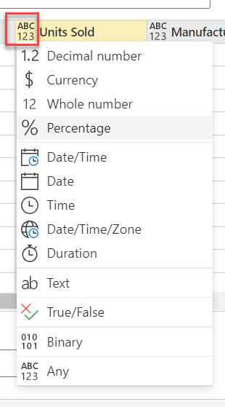

As you go through the creation process, Power BI creates a new dataset for you, and autogenerates a summarized view of your data. These autogenerated visuals propel you from raw data to insights faster than ever.

Changing the data you see in the report is easy, too. Use the **Your data** pane to add or remove fields from the report. Select and deselect fields to update what you want to measure and analyze. Power BI automatically plots meaningful charts based on your field selection. Read [Interact with autogenerated "quick" reports](https://learn.microsoft.com/en-us/power-bi/create-reports/service-interact-quick-report) to see all the ways you explore and modify these reports.

How do you navigate Power BI reports?

**To begin, open the Power BI service (app.powerbi.com).**

1. If the left navigation pane is collapsed, select the nav pane icon. to expand it.
2. Select Learn and scroll down to Sample reports. ...
3. Select the sample to open it. ...
4. The Power BI service installs the sample in your My workspace.
5. How to connect to data in Power BI? How to use the content pack to connect to google analytics? Mention the steps.

In **Power BI Desktop**, select **Get data** from the **Home** ribbon tab.

In the **Get Data** window, select **Online Services** from the categories in the left pane.

Select **Google Analytics** from the selections in the right pane.

At the bottom of the window, select **Connect**.

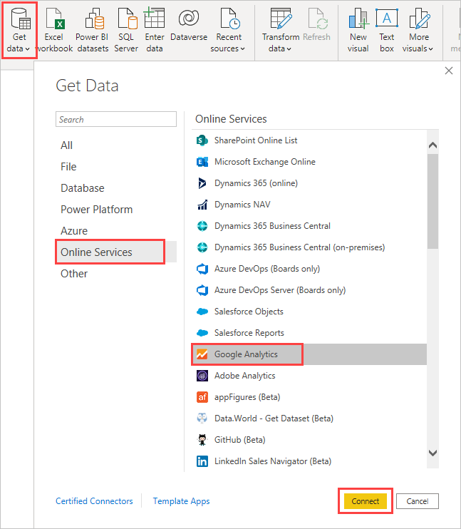

You're prompted with a dialog that explains that the connector is a Third-Party Service, and warns about how features and availability may change over time, and other clarifications.  
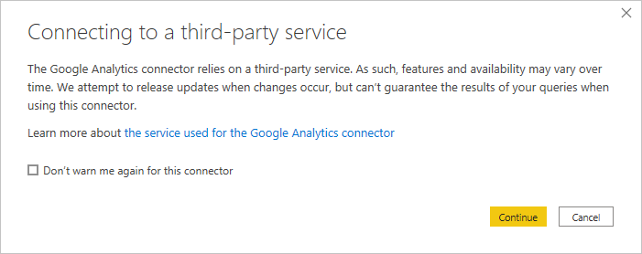

When you select **Continue**, you're prompted to sign in to Google Analytics.  
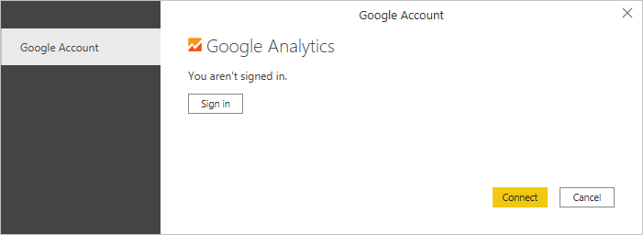

When you enter your credentials, you're prompted that Power BI would like to have offline access. This is how you use **Power BI Desktop** to access your Google Analytics data.

Once you accept, **Power BI Desktop** shows that you're currently signed in.  
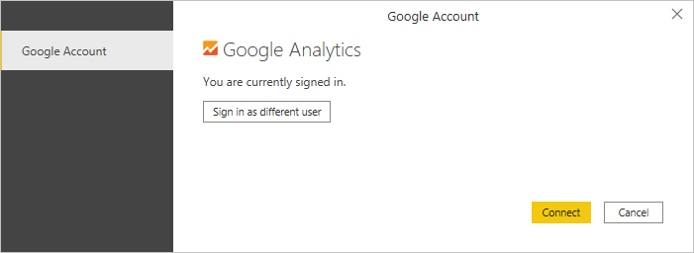

Select **Connect**, and your Google Analytics data is connected to **Power BI Desktop**, and loads the data.  
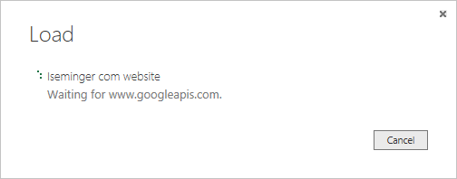

1. How to import Local files in Power BI? Mention the Steps.

**Manually import data to Power BI**

If you want to import Analytics data manually through Power BI, follow these instructions.

1. In Power BI, click **Get Data** in the lower left screen.
2. Under **Import or Connect to Data** > **Files**, click **Get**.

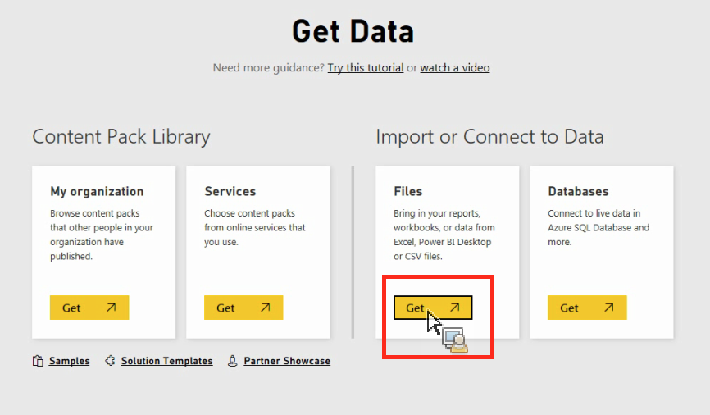

1. Click Local File.

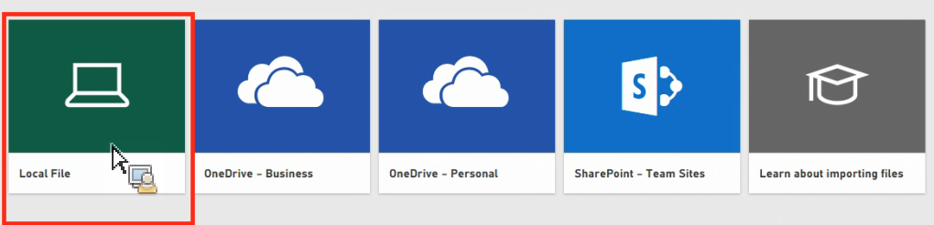

1. Choose which file to upload and click **Open**.
2. Click **Upload** under **Upload your Excel file to Power BI**.

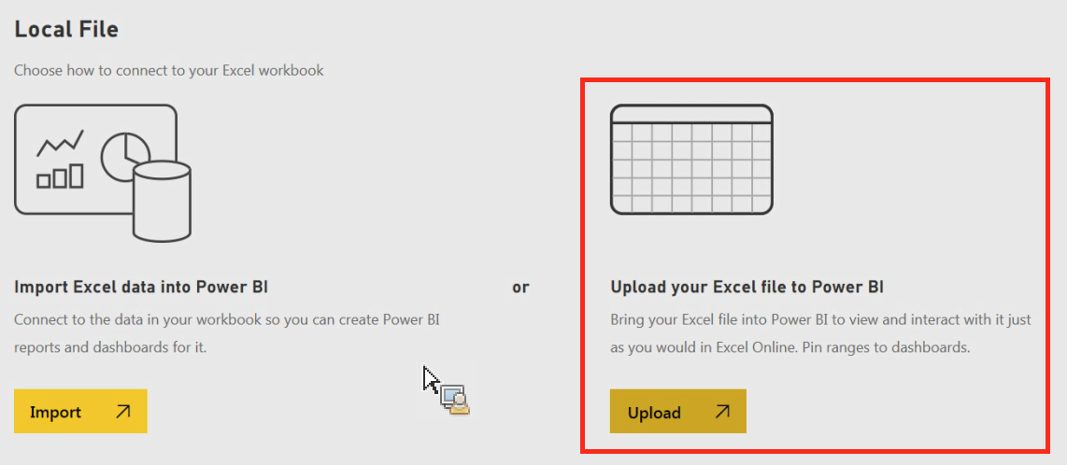

The message “Your file has been uploaded” should appear.

1. In Power BI visualization, what are Reading View and Editing view?

The Power BI service has two different modes for interacting with reports: [Reading view](https://learn.microsoft.com/en-us/power-bi/consumer/end-user-reading-view) for report business users and Editing view for report owners and creators. You need a Power BI Pro or Premium Per User (PPU) license to share reports and to edit reports created by others